Eastern Cyclo Cross League
Minutes of Committee Meeting held
Thursday 29th April 7:30pm
Present: Jo Denny, Steve Grimwood, Ian Poole, Ian Doe, Paul Moss, Daniel Doncaster, Jo Newstead, Dave Copland, Pete Whelan,
- Apologies
Ben Spashett (and is stepping down from the committee for person reasons), Mark Wyer
- Minutes of Last Meeting
Still no sign of Ron Hunt trophy.
Dave still to give Ian a list of addresses
Signed as a true record
- 2021-22 draft calendar
All previous organisers have been contacted for dates/details if they want to run into 2021/22. Deadline was last Friday and only had 6 responses.
Calendar at the moment
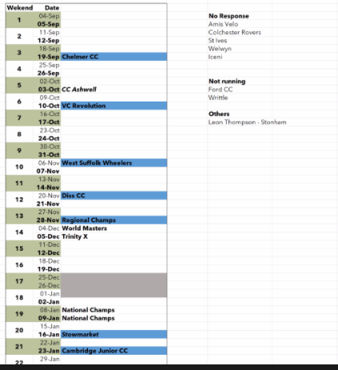
Welwyn are awaiting confirmation for Stanborough and needs organiser but hopeful it should go ahead.
Ford and Writtle are not running
Iceni are intending on using Horse Welfare but their committee needs to confirm
CC Ashwell are assuming that they can’t use Princess Helena as it is closing down. Looking at other venues, maybe Cambridge or Stanborough.
Tank museum in Norfolk is still a possibility
We will be flexible and can accommodate events at short notice.
Islington have expressed an interest to organise a cross in London but it’s in the East region.
- 2021 Worlds Masters Update
Few meetings with Trinity Park and everything going well. Problem with international travel so until that’s sorted not much to be doing. Travel update due from Government in June. Haven’t decided what to do with the Sunday race, probably an Open event. Week before will be a restricted field league race, maybe Regional champs for Eastern region riders only. Sunday after will be good for kids to have a go at a UCI standard course. Already been paid by East Suffolk. UCI invoice has been received.
- Treasurers Report
Not much to report as there have been no outgoings since last meeting. East Suffolk DC have paid the £10,000 sponsorship for the World’s Masters and we have been invoiced by the UCI for World’s Masters as well.
- Coaching update
The only report I have from Coaching and Development is that I am organising a meeting with our Development Workgroup and Matt Ellis, National Team Manager and Talent Development Coach to discuss how we can work with him and the impact on our Contenders sessions.
Matt Ellis is hoping to come out into the regions in terms of talent development and we need to encourage him to come into this area to hold some events/sessions. Trinity Park may be a good place to go. Matt will feedback to the next CX commission in a months time.
Welwyn have been putting some work into a permanent feature at the velodrome.
- AOB
  - Earthworks at CC Ashwell
Got a composting toilet in the field!
  - Ian Doe advise that hopefully we will have Commissaire courses available soon
  - Our condolences and memories to family and friends following the deaths of Tony Asplin and Graham Hart who sadly passed away this week. PM to get in touch with Colchester Rovers for Tony and Lee Rowland for Graham Hart
  - PM mentioned EPiC kitemark for equal prize money to be discussed at future meeting.
- Date of Next Meeting
Monday 5th July 7:30pm

